**CSE100 Project: Employee Management System**

**Final Document**

# TEAM DETAILS

|  |  |  |  |
| --- | --- | --- | --- |
| **RollNo** | **Name**  **(Firstname Lastname)** | **Email Id** | **Contact No.** |
| **AU2140088** | **Buland Shah** | **buland.s@ahduni.edu.in** |  |

**[1] PROBLEM DEFINITION**

|  |  |
| --- | --- |
| **Title of the project** | Employee Management System |
| **Objective/vision/main goal** of developing the software  application | To create a database system that stores important data of the employees. It also allows manipulation and addition/deletion of data for the purpose of keeping records. |
| **What Problem will be solved by the proposed software application** (or real-life need/use of the software application) | As real-world application, the software will help in digitization of numerous data. So instead of storing physical copies, data can be stored and maintained easily in the form of soft copies.  Furthermore, as the data is digitized it makes way for easier and enhanced data manipulation and analysis of the records for the company/organization. |
| **End-Users of the software:** different types of users/roles who are going to use the software like admin, customers, manager, employee, etc. | The targeted users for Employee Management Software are admins, managers who are responsible for keeping track of the employee records.  However, employees can be allowed to use software under certain restrictions like they can see the records without any manipulation or modification of data. |
| **Listing of**  **functionality/features/main modules** to be provided in the software to different end-users | Following are pre-visualized functionalities provided by the software :  1.) View the employee data table.  2.) Add a new employee record.  3.) Update a specific employee record.  4.) Delete employee record/records.  5.) Save changes and exit. |
| **Important System-outputs to be generated from the software** | The software will show the employee data table as output, including data that has being changed last time.  Furthermore, after saving of changes to table, a .txt/.dat file will be created storing all records. |

**[2] PROJECT DESIGN**

**2.1 User Interface Design** - Design of Menus, Input and Output Screens

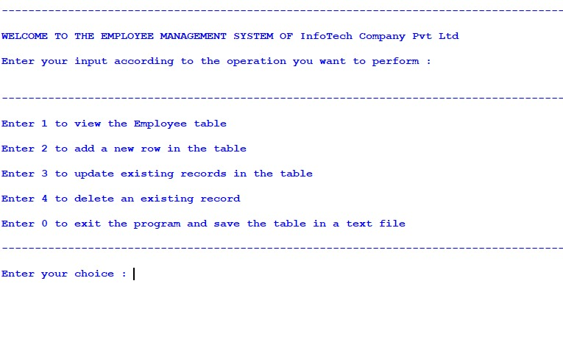

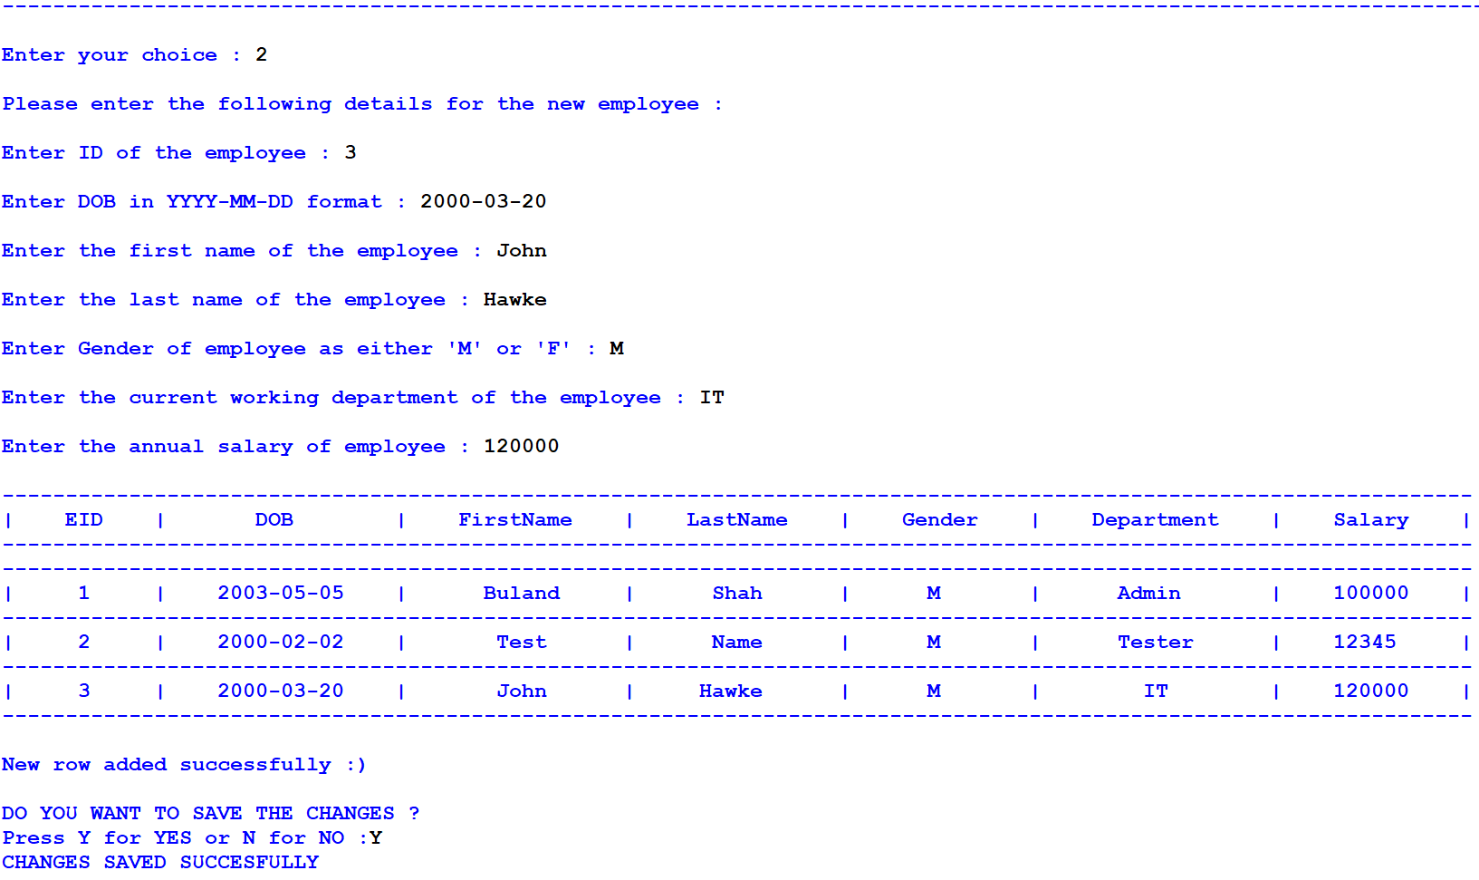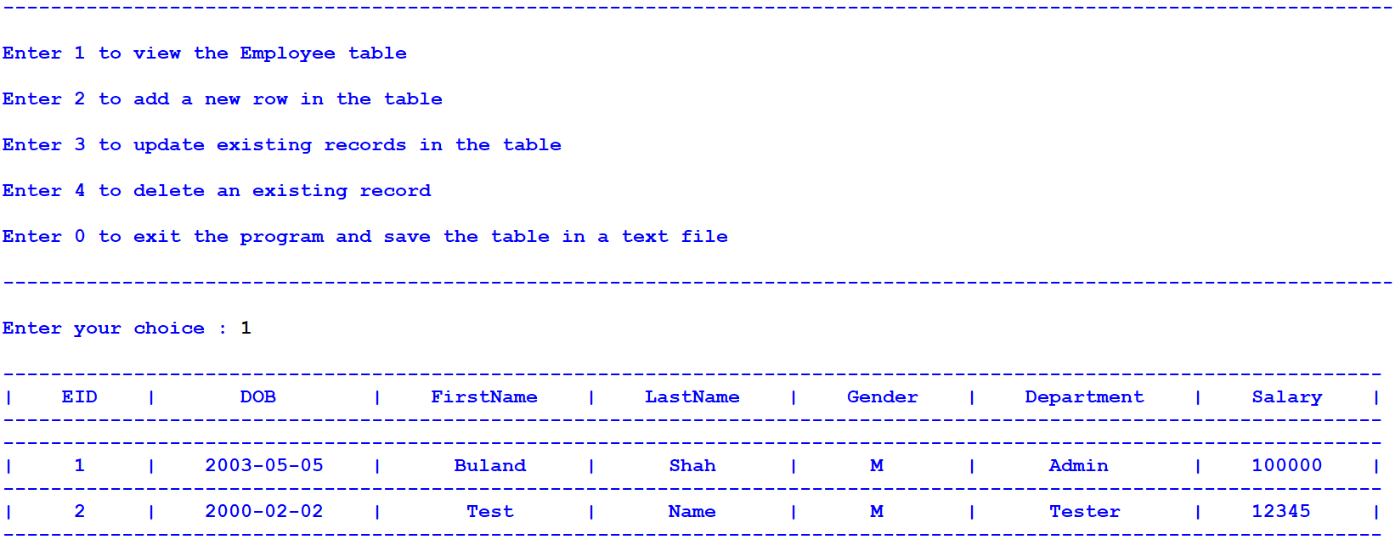

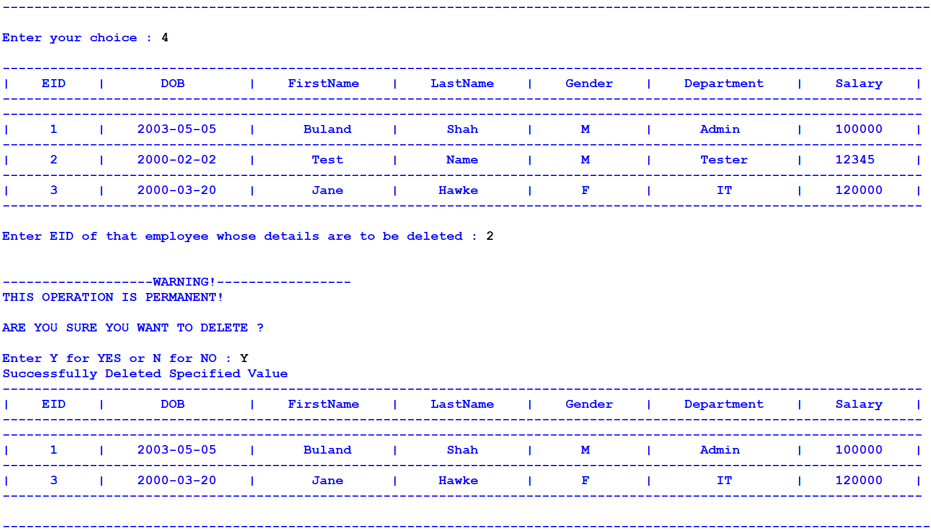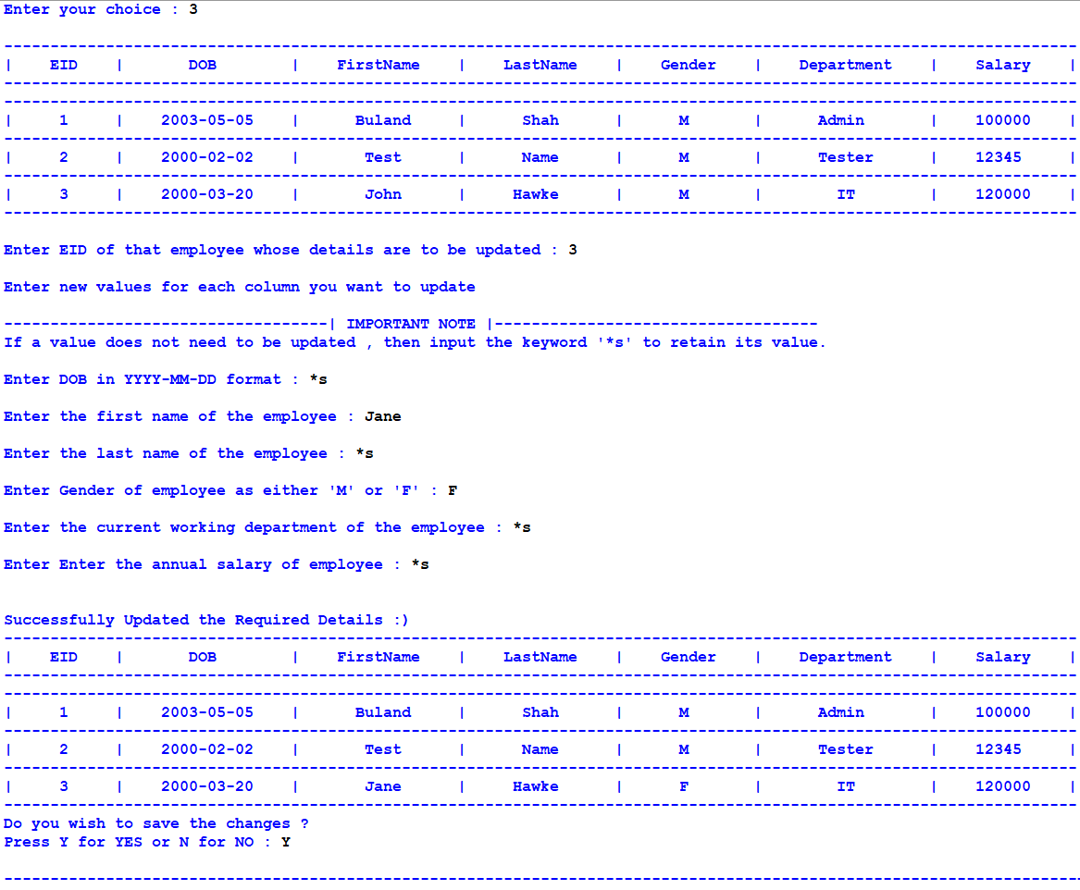

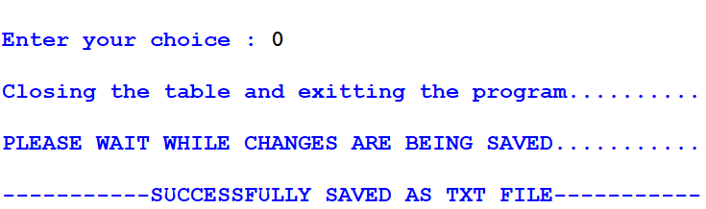

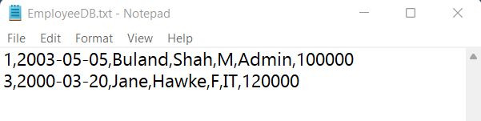

## 2.2 Database Design

* The program uses a data file in order to retrieve the records saved in it. After each successful data manipulation, the file saves the latest data.
* The filename and design will be as follows:
* **EmployeeDB.txt**

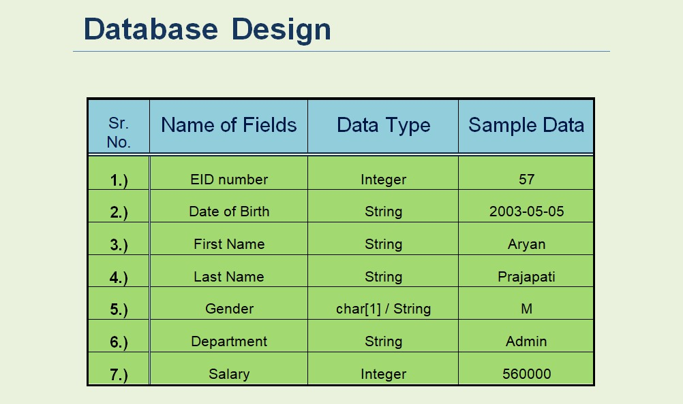

**[3] Algorithms**

The program consists of mainly 4 functionalities:

* Searching For Data
* Adding New Row To Table
* Updating Existing Row
* Delete Existing Row

Before starting with the main functionalities, lets discuss about the main module. The main module opens the “EncryptedDB.txt” file to fetch the existing employee records and store them in a list named as emp_data. The list consists of individual lists that contain a single row each. Note that the “EncryptedDB.txt” file contains the data in encrypted form and the main module decrypts the data accordingly.

## Search

1. Ask user to specify the column from which the search needs to be done and store as column
2. Ask user to enter the search value for that user-selected column and store it as value
3. Store the index of variable column as col_index
4. Initialize counter as 0
5. Create list result
6. Traverse all the values from the specified column of emp_data array through loop
7. In the loop, check if value is equal to any value of that column. If yes, then increase counter by 1 and append the whole row containing that value into result list
8. Outside the loop, check if counter is more than 0. If true, then print all rows from result list and if false, then print “No Such Record Found”

## Add

1. Initialize list named row
2. Ask user-input values for all fields(EID, DOB, FirstName, LastName, Gender, Department, Salary)
3. Append all inputted values in list row
4. Append row to emp_data

## Update

1. Initialize list row
2. Ask for the EID of the row which needs to be updated, from the user and store it in ID
3. Store the index of the row containing EID==ID from emp_data, in rowID
4. Print “Re-Enter The Values For All Fields”
5. Print “For the values that don’t need updation, type ‘*s’ ”
6. Ask for all the values and store them in the list row
7. Run a loop from iterator i = 1 to i = 6 ( step = +1 )
8. In loop, if row[i] != “*s” , then emp_data[rowID][i] = row[i]

## 4.) Delete

1. Ask for the EID of the row which needs to be updated, from the user and store it in ID

2. Run a loop from iterator i = 0 to i = 6 (step = +1)

3. Inside loop, if emp_data[i][0]==ID, the remove emp_data[i] from list

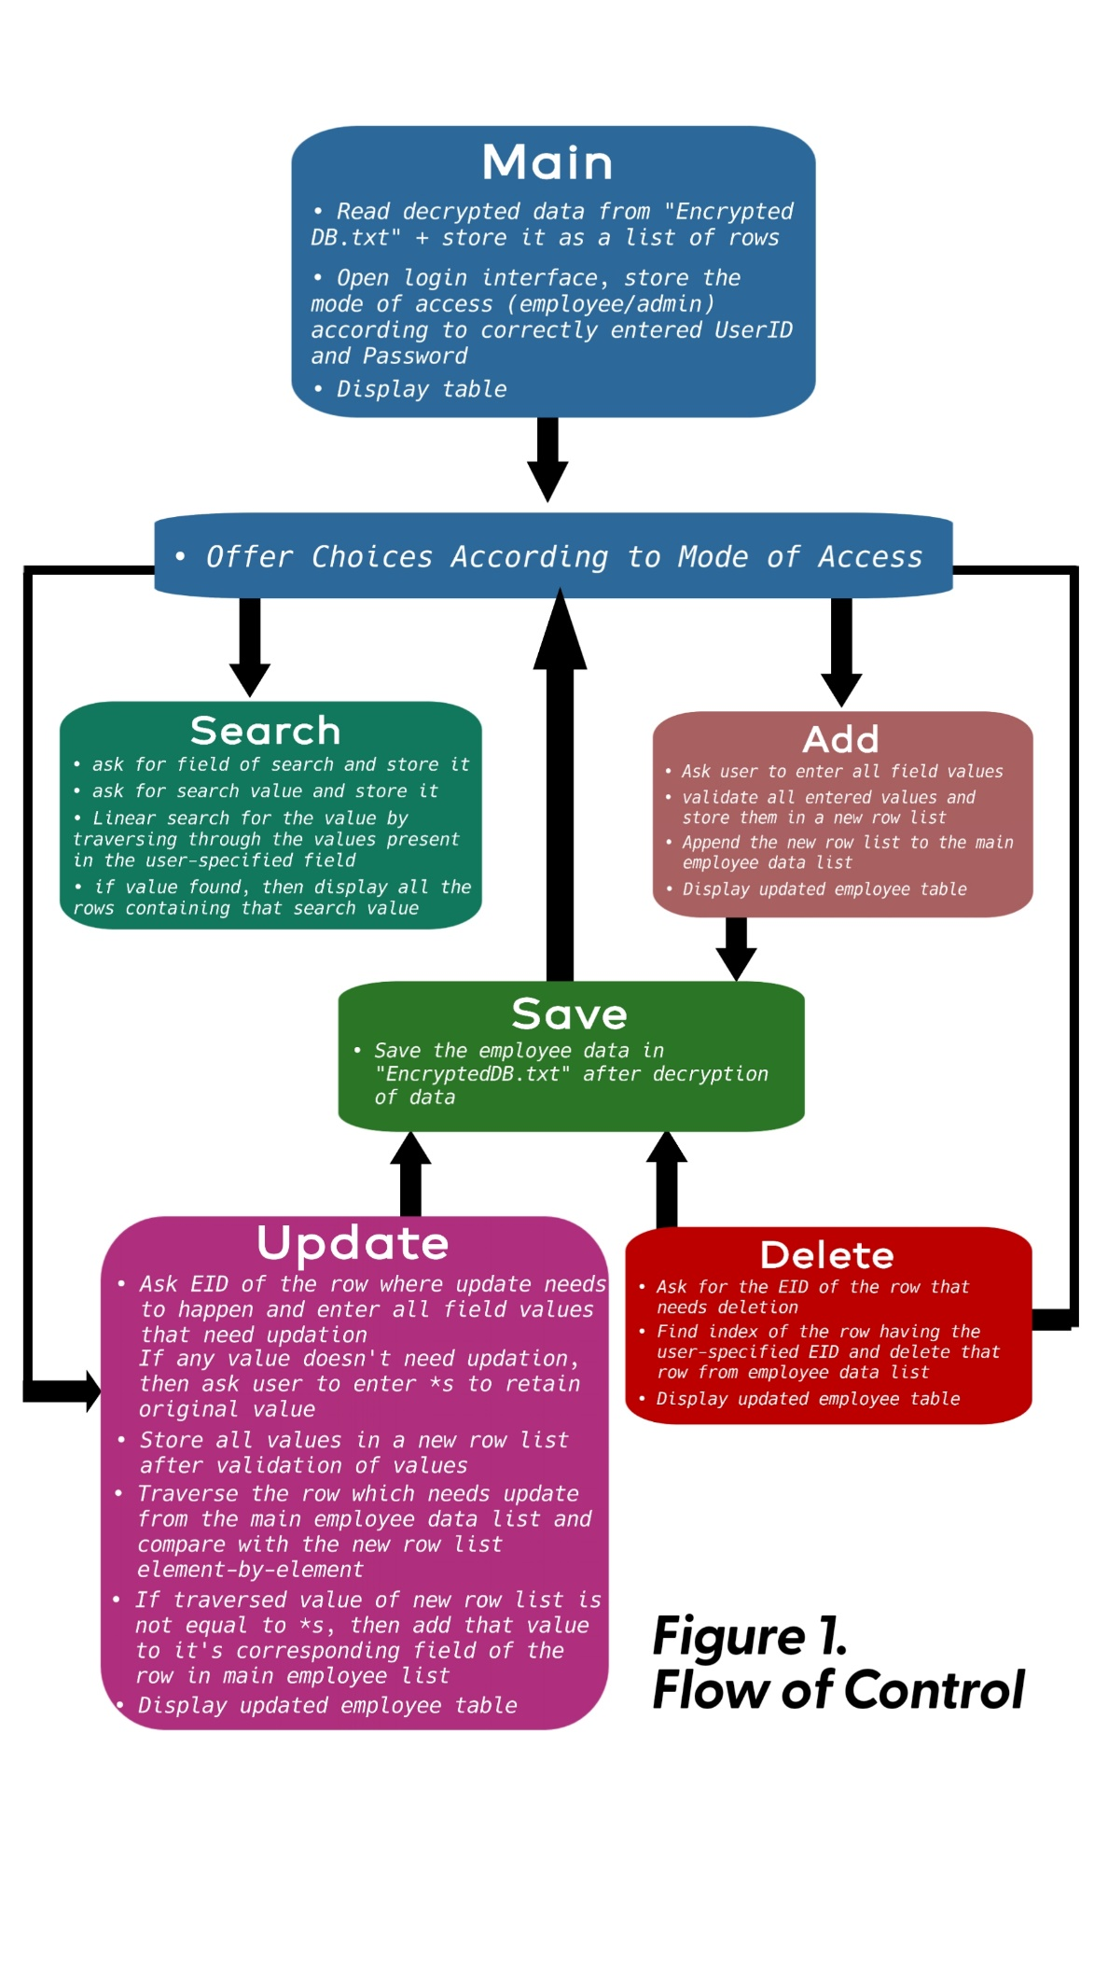

**4. Flow of Control**

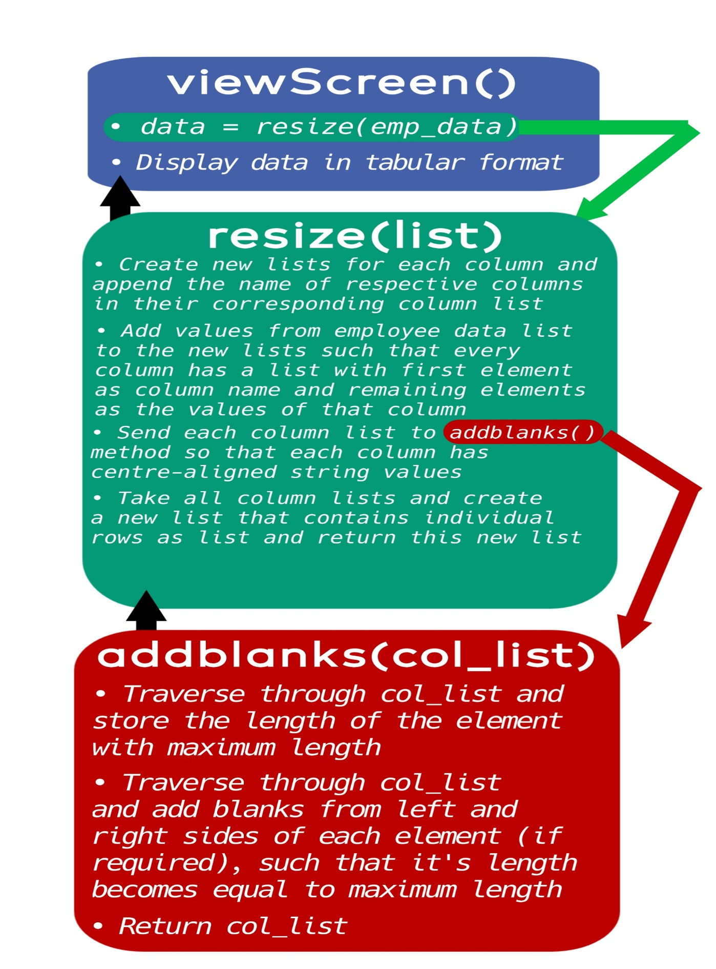

Detailed Flow of Control of Displaying Data in Table Form:

emp_data is a list containing individual rows as lists after reading the data from file “EncryptedDB.txt” once program starts.

Detailed Flow of Control of Login:

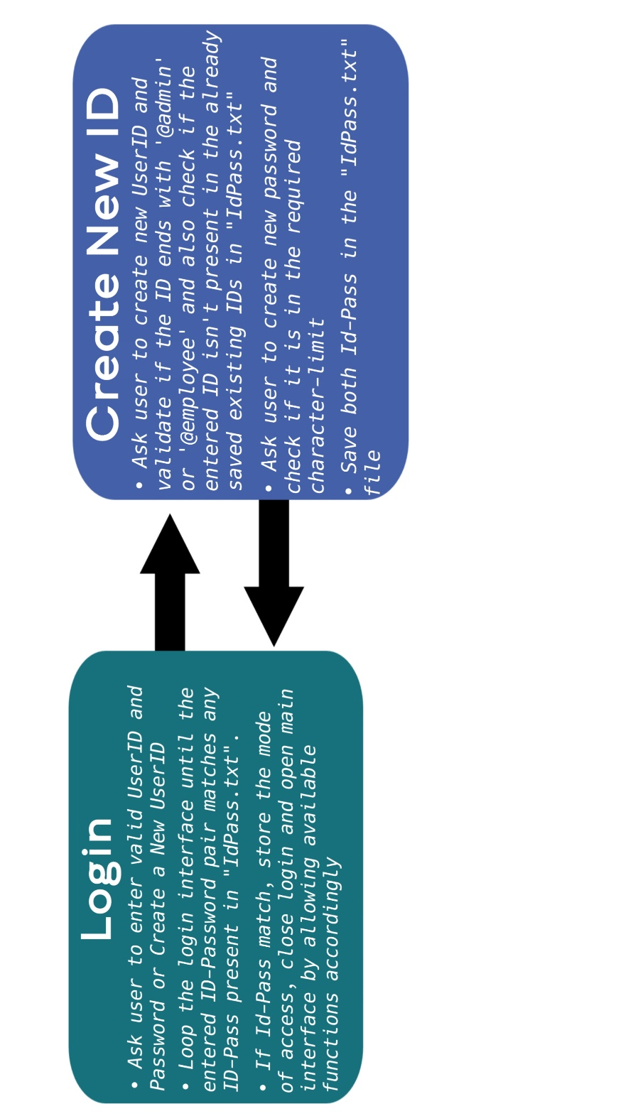

## A) Login Screen

**[5] Updated Project Design**

* Enter user ID and password to login into management system. Incorrect password or ID doesn’t give access to the software.

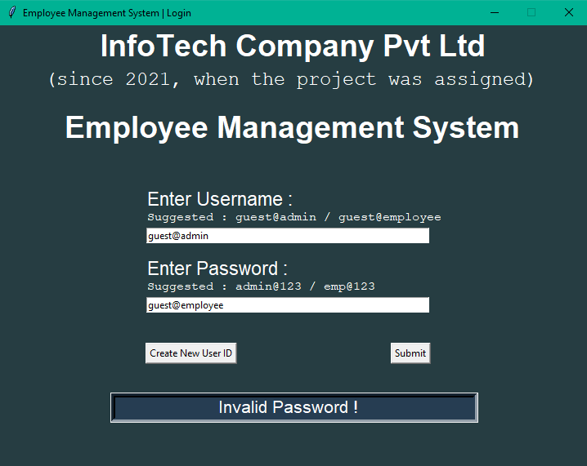

* In software interface there are various functionalities that can be performed on the employee data if user logs in through an admin User ID.
* However, Employee ID only provides only limited functionalities like to view employee data and searching data.

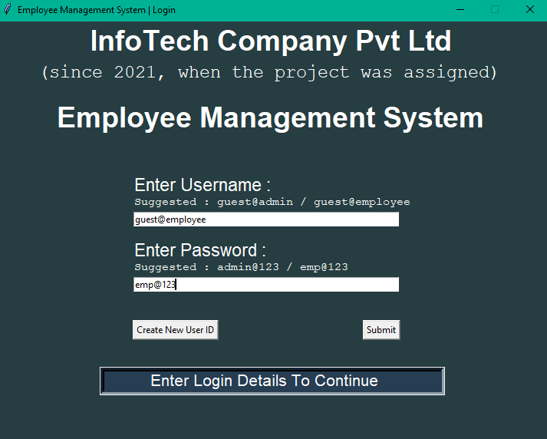

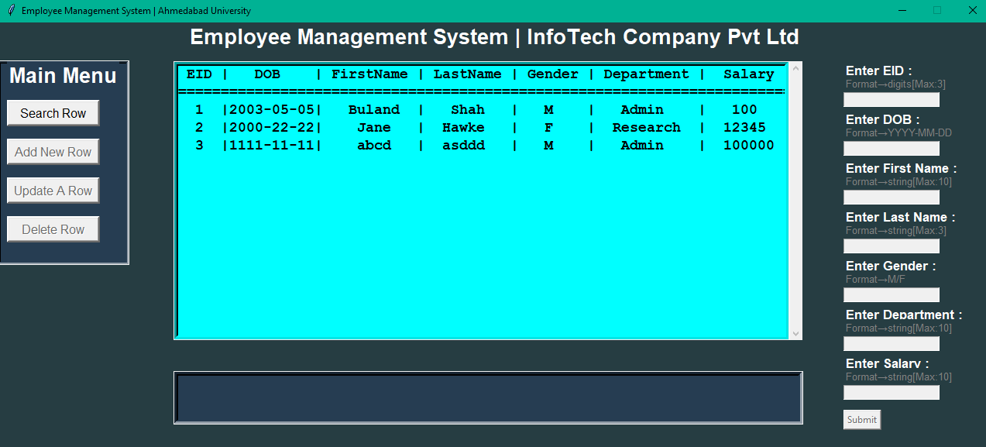

## C:\Users\Shree\Pictures\Screenshots\Screenshot (489).pngB) Main Interface

**1.)** SEARCHING RECORDS

* To search a record first click on ‘Search Row’ option then select the field that you want to search. Then write the data information to be searched.

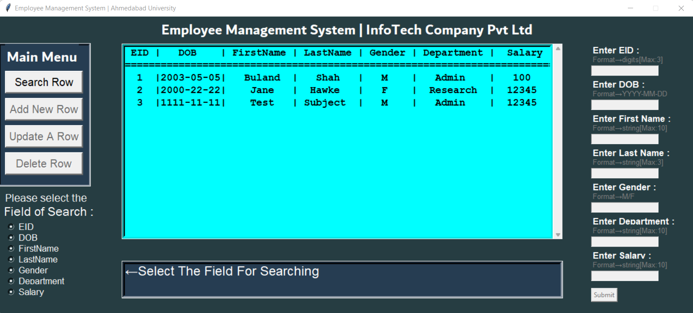

* After that, the searched item will be displayed on the main center display.

For example –

Searching for a department field value:

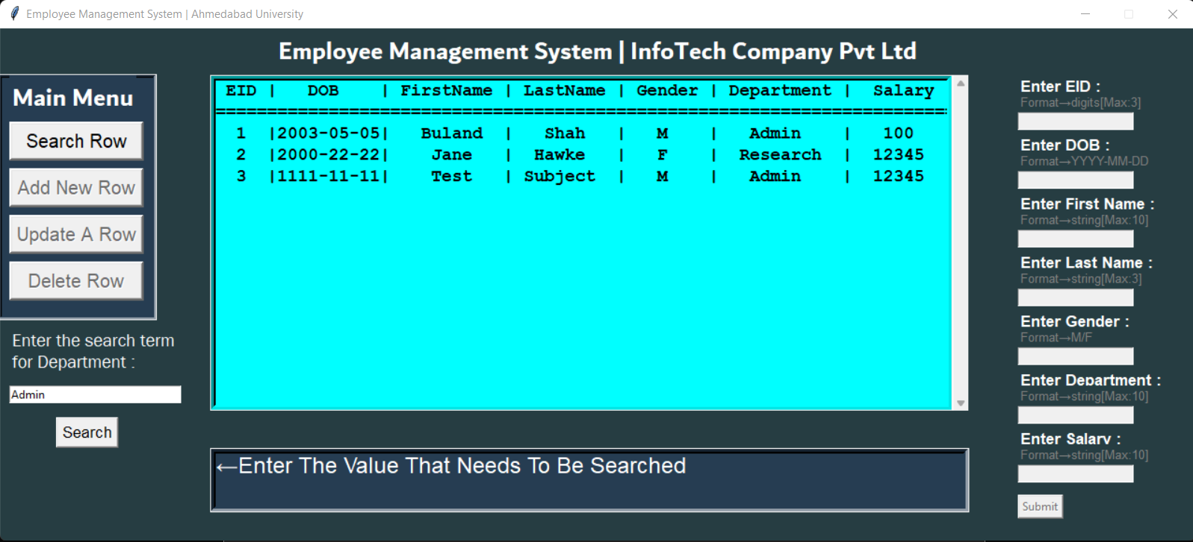

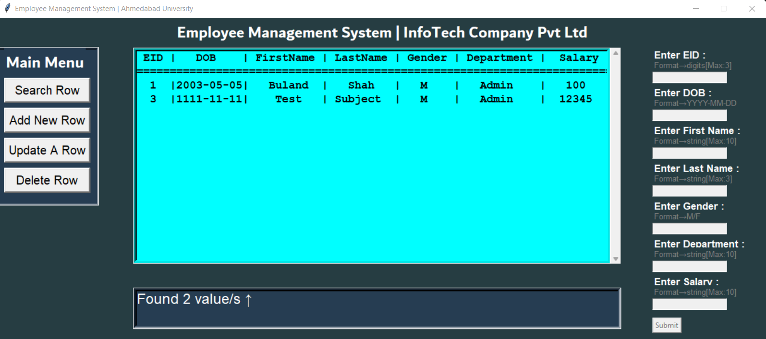

**2.)** ADDING NEW DATA

* 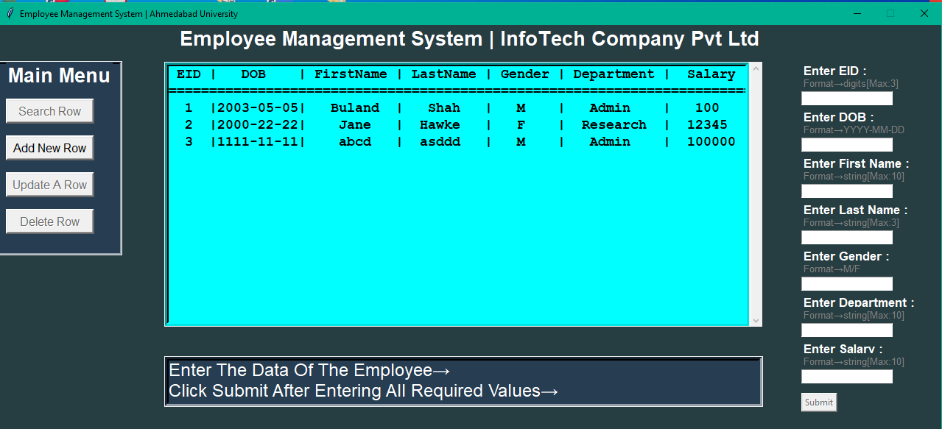To add a new row, click on ‘Add New Row’ then enter the data as per the prescribed format and click on submit after inserting all required data.

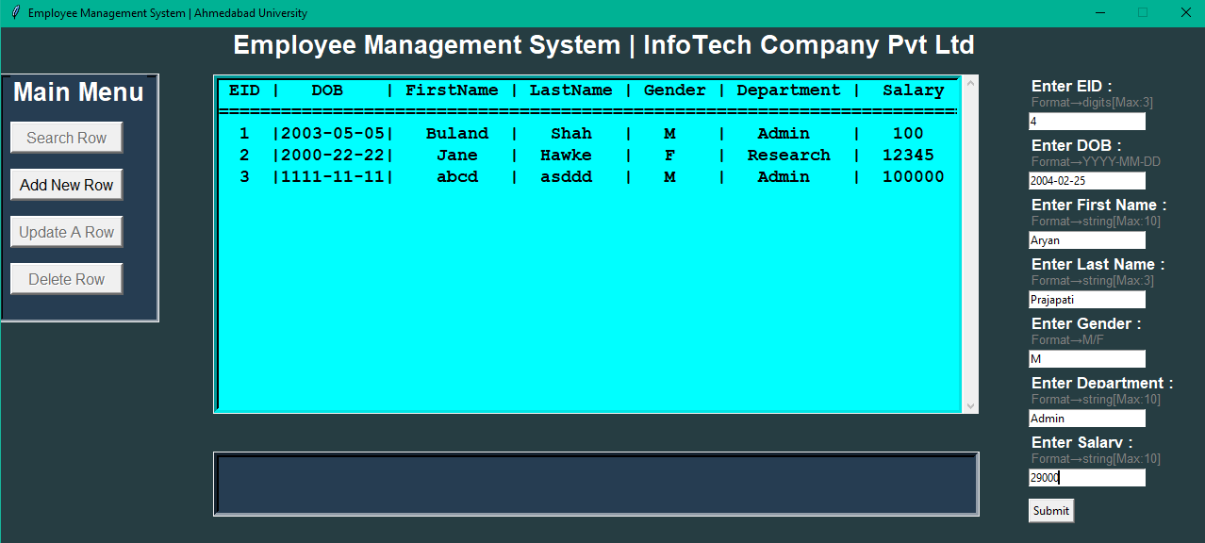

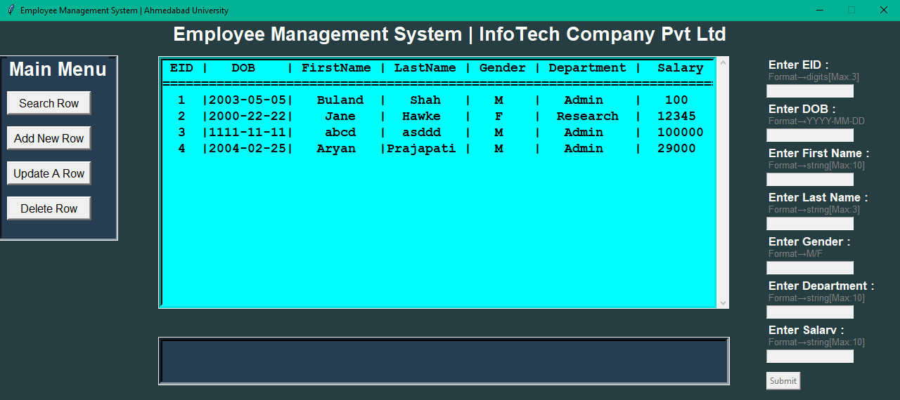

**3.)** UPDATING DATA

* To update a specific row click on ‘Update A Row’ option and then specify the EID number of the row that you want to update and write the updated values as per the format of required information. Write “*s” where you don’t want to update the previous data. Click on submit button after inserting all information.

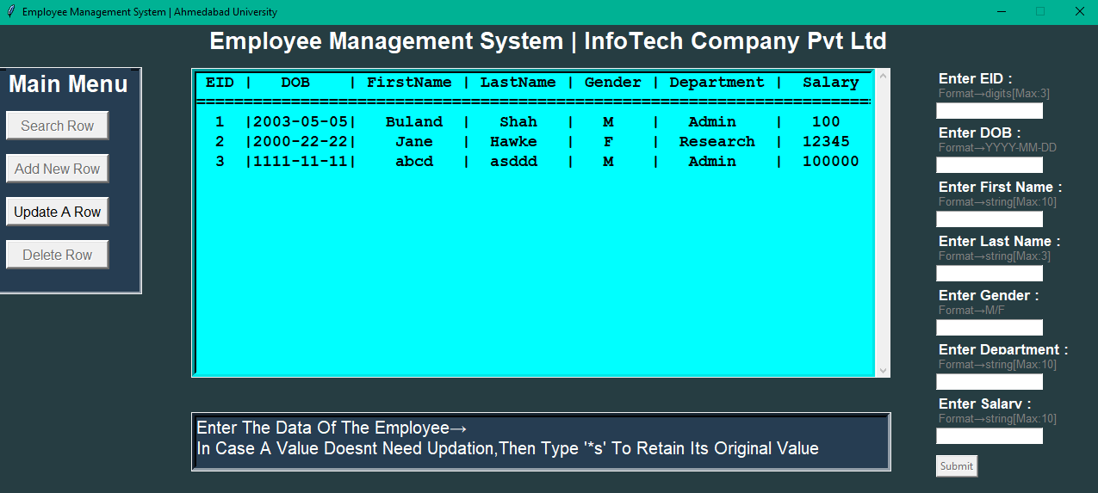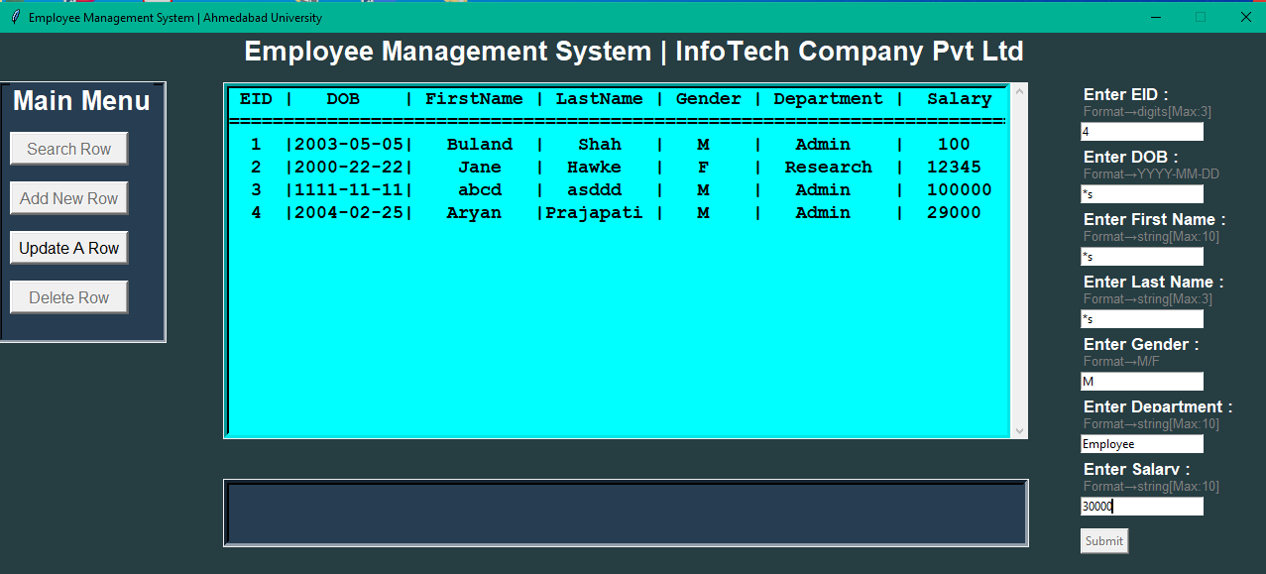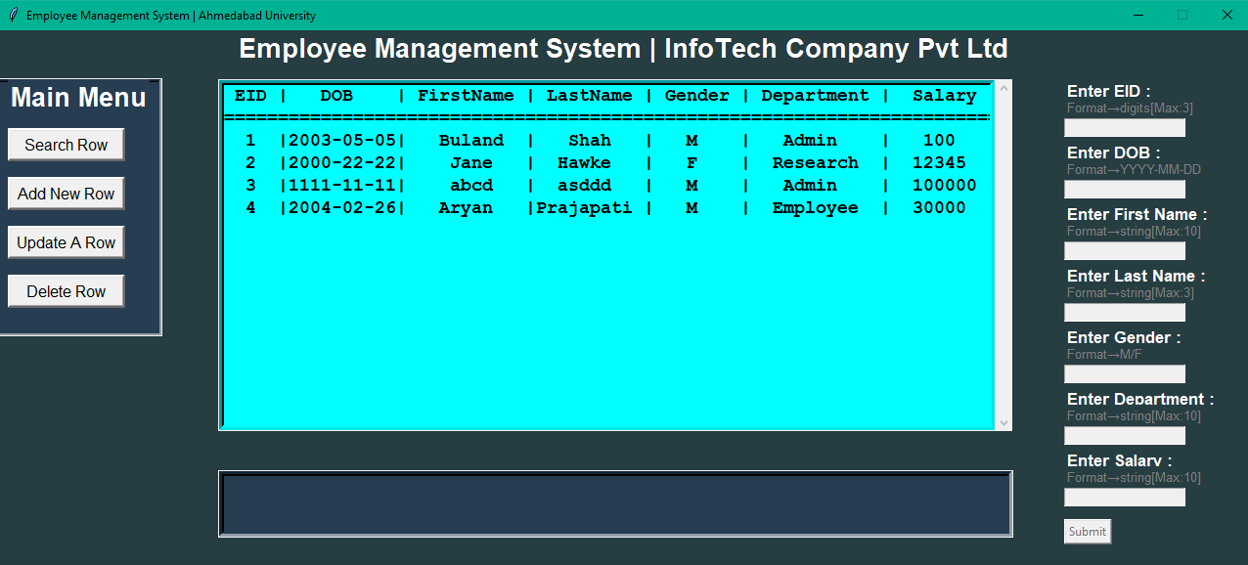

**4.)** DELETING DATA

* To delete a row click on ‘Delete Row’ option and specify the EID number of the employee that you want to be deleted and then click on submit button.

